
a
Company
Logotype

Cone Beam Computed Tomography- Report



Porur Dental X-rays & CBCT

Patient Name : Mr. Harikrishnan | Date of Report : 22.08.2025
Age/ Gender : 37 years/ Male | Region of Interest : CBCT Sectional Maxilla
Referring doctor: Dr. Selva Ganesh | Indication : Implant assessment
Clinical Notes: Nil
PATIENT INFORMATION

CBCT- Sectional Maxilla provided
CBCT – IMAGE DETAILS

RADIOGRAPHIC INTERPRETATION

- The maxillary alveolar ridge is present with normal trabecular pattern.
- Completely mission crown and root portion of 16.
- Distance between the teeth 15 and 17 at the level of CEJ: 8.06 mm.
- Distance between the teeth 15 and 17 at the coronal level:6.36 mm.

36 region
Distance between the alveolar ridge and the floor of the maxillary sinus (in mm)
IMPLANT ASSESSMENT

RADIOGRAPHIC IMPRESSION

- Partially edentulous region: 16

Kindly correlate with history and clinical findings


IMAGES FOR REFERENCE

RECONSTRUCTED PANORAMIC VIEW
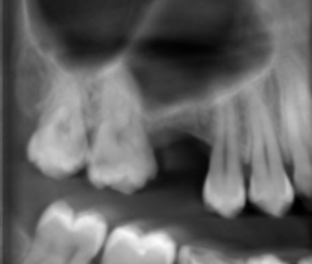

3-DIMENSIONAL VIEW
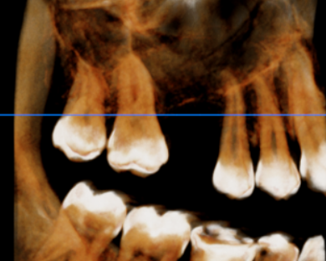

CROSS SECTIONAL VIEW

16 region | 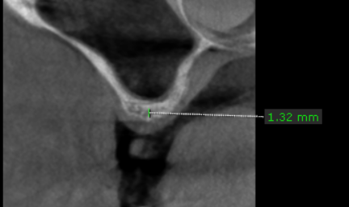

**** End of report ****

